**TASK-3**

**Old python code**

def compute(n):

if n < 10:

out = n ** 2

elif n < 20:

out = 1

for i in range(1, n-10):

out *= i

else:

lim = n - 20

out = lim * lim

out = out - lim

out = out / 2

print(out)

n = int(input("Enter an integer: "))

compute(n)

**New Code**

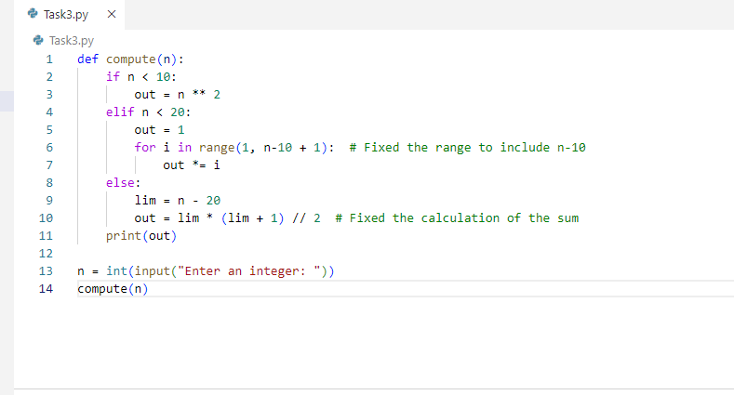

I have made the following changes to the script:

1. In the factorial calculation part ,I changed the range to range(1,n-10+1) to include the n-10 value in the factorial calculation
2. In the sum calculation part ,I simplified the calculation by using the formula for the sum of integers from 1 to n, which is (n*(n+1))//2.this correctly calculates the sum of all integer between 1 and (n-20)